**Instructions for Adding a VISA Resource for a VNA**

1. Launch the VNA application.
   1. Verify the TCP server is running on the VNA application by selecting System > Misc Setup > Network Setup > TCP Socket > ON
   2. Note the Port number (the default is 5025).
2. Launch the NI MAX – Measurement & Automation Explorer.
3. Right-click on “Network Device” in the tree on the left panel and select “Create New VISA TCP/IP Resource..”.  
   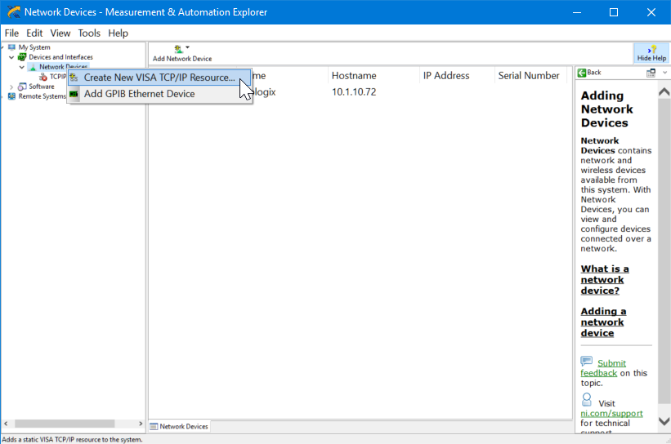
4. Select the “Manual Entry of Raw Socket” radio button and click “Next >”.  
   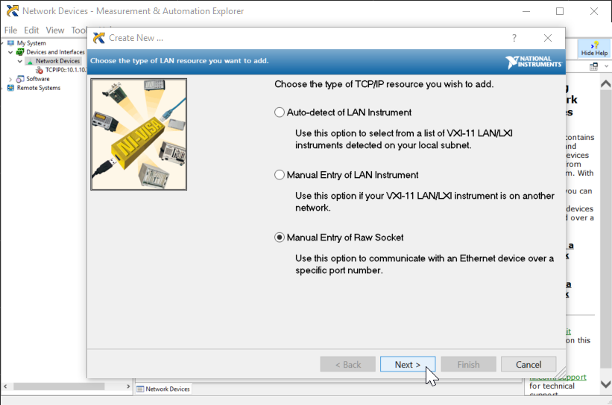
5. On the next screen enter “localhost” in the “Hostname or IP address” text box and the Port number of the VNA applications TCP Socket server (5025 by default) in the “Port Number” text box.  
   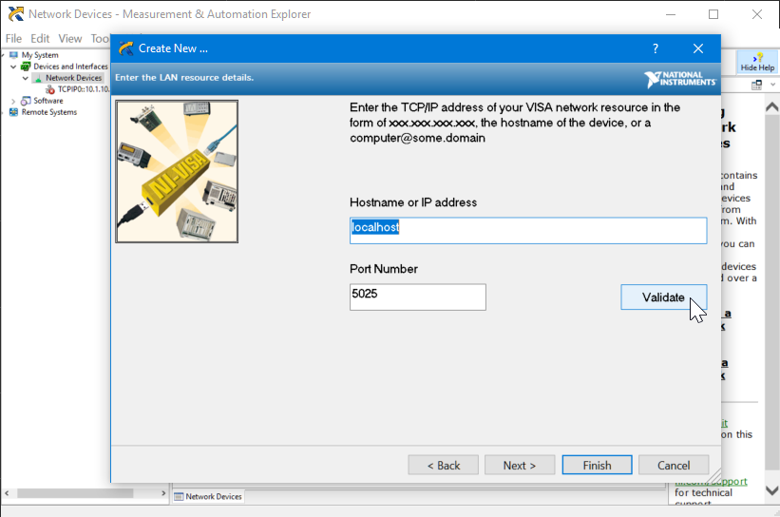
6. Click the “Validate” button to make sure the values entered are correct. Then click “Finish”.
7. If desired, enter a name (e.g., VNA) for the VISA resource you’ve created and click the “Save” icon.  
   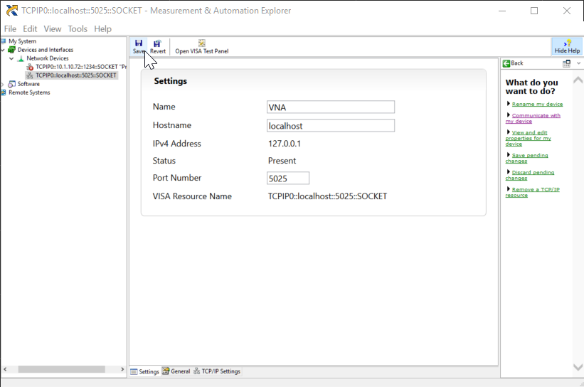  
     
   The VISA resource is now created and ready for use.